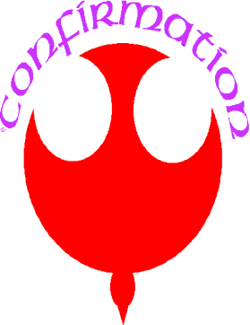
Confirmation

1. Who is the usual minister of Confirmation?

A. A deacon B. The priest C. The Bishop

2. Those who are to be confirmed are anointed on the forehead with holy _______ in the form of a cross.

A. water B. chrism C. ashes

3. When does the bishop bless this?

A. Palm Sunday B. Holy Thursday C. Easter Sunday

4. What does this symbolize in Confirmation?

A. Strength B. Joy C. Peace

5. Confirmation is the Sacrament through which ____________ comes to us in a special way.

A. God the Father B. the Son C. The Holy Spirit

6. When do we receive this during Confirmation?

- when the Sign of the Cross is drawn on the forehead.
- when the minister of Confirmation lays his hands upon your head.
- when we genuflect and make the sign of the cross.

7. What essential words are said by the minister of Confirmation?

- Peace be with you and now go forth and be His witness.
- You are now confirmed.
- I sign you with the sign of the cross and I confirm you with the chrism of salvation, in the name of the Father, and of the Son, and of the Holy Spirit.

Answers

1. C

2. B

3. B

4. A

5. D

6. B

7. C

